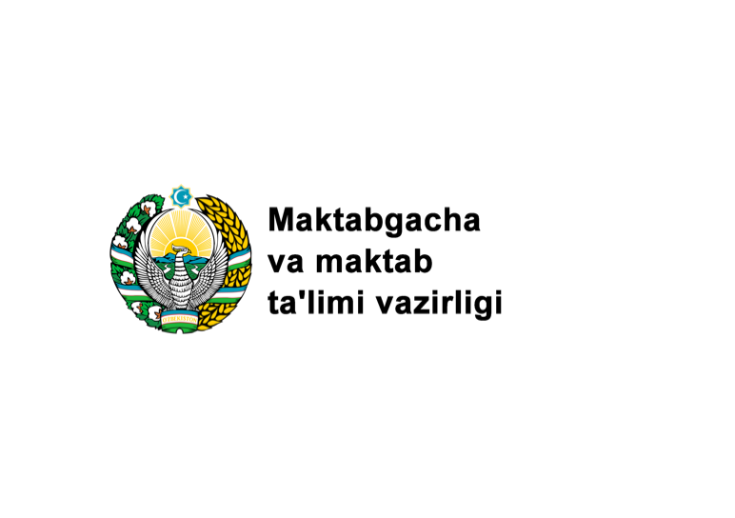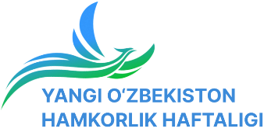

**International conference on the topic: “Uzbekistan - a healthy and educated society”**

**PRESS RELEASE**

On July 5, 2023, an international conference was organized on the theme ***“Uzbekistan: healthy and educated society”*** at the Event Hall of the “Uzbekfilm” of Uzbekistan.

As part of the Week of International Cooperation on the theme "***New Uzbekistan: Progress, Innovation, and Knowledge***", which took place on July **3–4** in Tashkent, the forum brought together representatives of the education sector of international organizations and foreign countries.

**The primary object of this weekly event** is to discuss the role of education and science in the human capital of New Uzbekistan, their formation and development, current trends in reforming the education system, their application in practice after studying world experience, and the results of this exchange—familiarizing the general public with the reforms carried out in the field of education and science in Uzbekistan.

The parties discussed in detail the analysis of broad changes in this area in recent years within the framework of the session on the topics *"Quality education is a solid foundation for the New Uzbekistan", "Human capital: global problems and development trends",* the content of the reforms of preschool and school education carried out in the republic in recent years.

In the Republic of Uzbekistan, in the last seven years, important changes in the system of preschool and school education have been rapidly carried out. To date, the enrollment rate for preschool children in preschool education has increased from **27.7** percent in 2017 to **71.8 percent** today. At the same time, more than **2 million** children receive education in preschool educational institutions.

To achieve these indicators, over the past five years, the number of preschool education organizations has increased from **5,211 to 29,420.** In particular, **6,598** state, **833** private, **1,313** non-state, and **20,676** family non-state preschool educational organizations have been opened.

Also, as a result of the construction of 438 new state preschool educational institutions, 60,335 new places were created, and as a result of the reconstruction of 2,064 preschool educational institutions**, 13,980 new places** were created. **785** public preschool educational institutions have been completely renovated.

Various types of free pre-school education programs have been introduced for low-income families in need of social protection for their children. As part of the ***"Aklvoy"*** project, **387** mobile groups have been formed to educate more than **7,000** children in **142** settlements where there are no conventional preschool educational institutions.

Thanks to the attraction of foreign investments in the field of preschool education, international agreements were signed in the amount of 141 million US dollars.

In Tashkent, a system of training qualified primary education specialists has been established on the basis of a branch of the Puchon University of South Korea and the "Federal Budgetary Higher Educational Institution" of the Russian State Pedagogical University named after A.I. Herzen.

The number of teachers in the primary education system has increased from **58,400** people in 2017 to **151,746** people. At the same time, the share of teachers with higher education increased from **21.6% to 34%.**

New forms of assistance for inclusive educational initiatives and children with disabilities have been introduced, including the creation of specialized institutions, such as the Imkon Rehabilitation Center in the cities of **Nukus, Karshi, and Kibray district.**

Together with specialists from the World Health Organization, standards for the nutrition of children in educational institutions have been developed and implemented, including a list of food products and methods of cooking.

In 2022, in Tashkent, following the results of the World Conference on Early Childhood Care and Education, organized by UNESCO. The Tashkent Declaration was adopted, outlining strategic directions in the field of primary education for the next *10 years.*

By the relevant Decree of the President of the Republic of Uzbekistan, the “Concept for the Development of the Public Education System until 2030” was approved, which defines a 10-year strategy for improving the national education system and makes efforts to reform the public education system.

Today in Uzbekistan, there are **10,104 general education schools**, **14 presidential schools,** **166 specialized** schools, and **219 Barkamol Avlod**. The number of students increased from **4.8 million** in 2016 to 6.4 million. The number of teachers teaching in general education schools is **527,000.**

In recent years, the education system of Uzbekistan has made significant progress in international rankings and education indices. It is noteworthy that the Human Development Index has risen from ***108th to 101st place***, the educational component of the Human Development Index has risen from 81st to 71st place, the Global Innovation Index has risen from ***122nd to 82nd*** place, and the Human Capital Index in the Global Innovation Index improved from ***76th to 65th.***

In total, over the past seven years, construction projects have been carried out in Tashkent and reconstruction work has been done in **5,137** schools, resulting in the creation of **643,000** new student places. In addition, through grants, investments from international financial organizations, and appropriations from the state budget, **6,251** modern computer classes.

The number of private non-state educational institutions increased significantly, reaching **364**, which is almost six times more compared to 2017.

Participation of Uzbekistan in international assessment studies, such as PIRLS, TIMSS, PISA, and TALIS, as well as such indices as the Human Capital Index (2020), is ensured. Activities to assess the knowledge of teachers and students in relevant subjects were carried out as part of ***PIRLS 2021 and TIMSS 2023.***

So far, a decision has been made that the system of providing free meals to primary school students in the Orolbuyi district will be introduced for secondary schools in all regions of the republic starting with the new academic year.

**37** medals were won by students of presidential, creative, specialized, and boarding schools at international olympiads.

By the Decree of the President of the Republic of Uzbekistan, **14** Presidential Schools and the New Uzbekistan University were established in various regions. These educational institutions, using the curricula of prestigious foreign higher education institutions, are currently preparing highly qualified, globally competitive, forward-thinking specialists in various fields.

***Information service of***

***Ministry of Preschool and School Education***

**EXCERPTS FROM THE SPEECHES OF THE CONFERENCE PARTICIPANTS:**

**Munir Mamedzadeh**, head of the **UNICEF** representative office in Uzbekistan: “Uzbekistan today is at the crossroads of history, striving to achieve new milestones in the development of education. Realizing the importance of quality education for the sustainable development and well-being of the people, the government of Uzbekistan has made great efforts to implement reforms in the field of education. However, these reforms require strong cooperation and support of international organizations, and we are pleased to participate in the implementation of these reforms”.

**Matthew Goldie-Scott**, **an international expert on education**, a member of the working group for the development of the program for the development of the education system of Uzbekistan in 2023-2026: “However, to achieve a high level of education, it is necessary to implement reforms and changes. I am glad to see that Uzbekistan is making a firm move in this direction. Introduction of modern methods of teaching, updating of educational programs, development of quality educational materials and use of advanced technologies are integral components of quality education. Uzbekistan has already made significant progress in the field of education and science. However, we need to continue cooperation on increasing the convenience of education, improving the quality of teaching and ensuring equal opportunities for all citizens”.

**Aslan Ibrahim**, *head of the National School in the United Arab Emirates and an international expert on education*: "I am aware of the creation of a national curriculum of general education subjects with the participation of local and international experts in order to improve the quality of education in the schools of your country. Based on it, great importance in students' acquisition of new knowledge is gained by creating 420 titles of new generation textbooks, localizing textbooks of Cambridge, Klett Publishing House, and Herzen University, and implementing *79 internationally recognized teaching-methodical manuals and textbooks of English, German, and Russian language subjects*. Also, for the first time, the participation of Uzbekistan's educational institutions in international assessment studies (PIRLS, TIMSS, PISA, TALIS) and indices (**Human Capital Index - 2020**) is ensured, and we can observe that Uzbekistan's position in international rankings is improving in recent years”.

**Steve King**, director of the department of educational services of the Cambridge Assessment organization: “Modern methods of education and training have been introduced in Uzbekistan, and we witnessed that work is being done to improve the qualifications of educators of preschool educational institutions. Your country also focuses on creating comfortable conditions for all children from preschool educational institutions, including children with disabilities.

In Uzbekistan, the main attention is paid to bringing the education system to a new level, improving the quality of education, training highly qualified pedagogues. Also, efforts are being made to create conditions for education that meet the requirements of the time.”

**Hiromitsu Sakat**a, director and executive manager of *KEI Advanced educational organization*: “In the field of education, we are implementing several projects in Uzbekistan in cooperation with the Japan International Cooperation Agency (JICA).

One of them is the project "Japanese-style academic achievement assessment model" aimed at assessing the knowledge of school pupils in mathematics.

Within the framework of this project, we conducted 4 tests with 8-9-10 grade pupils of **40 general, 10 private and 2 presidential schools** and analyzed the results and presented them to relevant organizations. As part of the project, which has been running since 2021, we have witnessed that there were big changes between the results of the 1st trial test and the 4th trial test, especially the results of the pupils of the presidential schools surprised us.”

**Vijay Kumar**, director of the Department of Educational Innovation and Technologies of the Massachusetts Institute of Technology - first deputy dean: "Massachusetts Institute of Technology has established cooperation with New Uzbekistan University not to organize a ready-made educational process, but to create a team that can introduce the best experience by improving the qualifications of specialists.

In my opinion, in terms of school education, first of all, it is necessary to pay great attention to human capital, including improving the qualifications of pedagogues and evaluating them based on international standards.

In general, Uzbekistan is following this path. For example, the establishment of a separate structure aimed at evaluating pedagogues in the ministry system, including the Pedagogical Skills and International Evaluation Center, is a proof of my statement”.

**Friederika Hettinger**, general director of the foreign organization of the Technical University of Munich “TUM International GmbH”: “I would like to touch on the system of Presidential educational institutions, which is a unique model of working with talented young people, which has made a big turn in education, especially in school education.

I believe that introducing this system to other schools will lead Uzbekistan to great success.

I hope that we will share our best experience in this regard and use all our capabilities to achieve great goals together.”

***Information service of***

***Ministry of Preschool and School Education***